Technical Design for Memory Card System

Revision History

Issue | Date | Person | Reason
0.1 | April 04, 2002 | Cary Brisebois | Creation
1.0 | April 12, 2002 | Cary Brisebois | Reviewed by team and released

Description

Introduction
The purpose of this document is to describe the communication between systems that use the memory card system. The memory card system in SRR 2 will be very similar to SRR 1 with the exception that in SRR 1 it was very difficult to make changes to the system as is was undocumented and convoluted. For SRR 2 the system will be cleaned up and documented.

Requirements
The memory card system must:
- Comply with the TRC/TCR requirements of all platforms.
- Present a high-level system for accessing (saving/loading) game data to the platform specific media.
- Supply information on state of the memory cards (and hard drive on Xbox) and the state of the hardware (has new media been added or removed recently).
- Support only one save file per memory media resource.

References
- Read TRC/TCR guidelines for Xbox, GC and PS2
- Talked to Joel DeYoung about memory card system from SRR 1
- Talked to Chuck Chow about FE requirements

Technical Design

Relationships
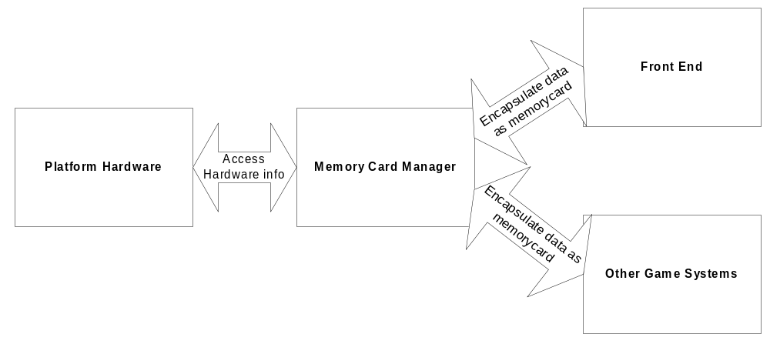
The memory card hides the hardware devices through data encapsulation

The front end and any automatic data saving/loading system do not need to know the specifics of the hardware they are saving too. Therefore it is up to the Memory card manager to act as a go-between for accessing the memory media. The Front end and other systems will only deal with high-level Memory card objects requested from the Memory Card Manager.

Interface

class IMemoryCard
{
public:
IMemoryCard() {};
virtual ~IMemoryCard() {};

enum
{
MAX_SAVE_SLOTS = 8 //This is the number of saved games per card
};

enum State
{
READY,
LOADING,
SAVING,
FORMATTING,
ERROR
};

enum Error
{
SUCCESS,
NO_SAVE_FILE,
FULL,
UNFORMATTED,
BAD_READ,
BAD_WRITE,
NOT_MOUNTED,
CORRUPT
};

virtual State GetState() const = 0;
virtual Error GetError() const = 0;
virtual unsigned int GetFreeBlocks() const = 0;
virtual unsigned int GetUsedBlocks() const = 0;
virtual const char* const GetName() const = 0;
virtual unsigned int GetPort() const = 0;
virtual unsigned int GetSlot() const = 0;
virtual bool HasSavedGame() const = 0;

virtual void Format( FormatCallBack, void* caller, void* data = 0 ) = 0;
virtual void Save( unsigned int saveSlot,
SaveData,
SaveCallBack,
void* caller,
void* data = 0 ) = 0;
virtual void Load( unsigned int loadSlot,
SaveData,
LoadCallBack,
void* caller,
void* data = 0 ) = 0;
};

The IMemoryCard interface is the interface used by all systems trying to load or save data to logical memory cards (e.g., front end, or auto-saving logic).

class MemoryCard : public IMemoryCard
{
public:
MemoryCard();
virtual ~MemoryCard();

enum
{
MAX_NAME_LENGTH = 256
};

IMemoryCard::State GetState() const;
void SetState( IMemoryCard::State state );

IMemoryCard::Error GetError() const;
void SetError( IMemoryCard::Error error );

void SetFreeBlocks( unsigned int freeBlocks );
unsigned int GetFreeBlocks() const;

void SetUsedBlocks( unsigned int usedBlocks );
unsigned int GetUsedBlocks() const;

void SetName( const char* name );
const char* const GetName() const;

void SetPort( unsigned int port );
unsigned int GetPort() const;

void SetSlot( unsigned int slot );
unsigned int GetSlot() const;

void SetHasSavedGame( bool hasSavedGame );
bool HasSavedGame() const;

private:
IMemoryCard::State mState;
IMemoryCard::Error mError;
unsigned int mFreeBlocks;
unsigned int mUsedBlocks;
char mName[MAX_NAME_LENGTH];
unsigned int mPortID;
bool mHasSavedGame;
};

The MemoryCard class is the class that interfaces with the hardware state and is only modified by the MemoryCardManager. All other classes need to use the IMemoryCard interface.

class MemoryCardManager
{
public:
static MemoryCardManager* GetInstance();

unsigned int GetNumMemoryCards( RequestCallBack,
void* caller,
void* data = 0 );
IMemoryCard* GetMemoryCard( unsigned int whichCard );
bool IsStatusChanged( RequestCallBack,
void* caller,
void* data = 0 );

private:
static MemoryCardManager* mInstance;

//Singleton
MemoryCardManager();
virtual ~MemoryCardManager();
};

MemoryCardManager is the singleton pattern object that deals with the hardware level memory card and hard drive information. The MemoryCardManager gives the rest of the game access to this information through the IMemoryCard interface. All physical changes to available devices go through the MemoryCardManager.

Component Class Diagrams
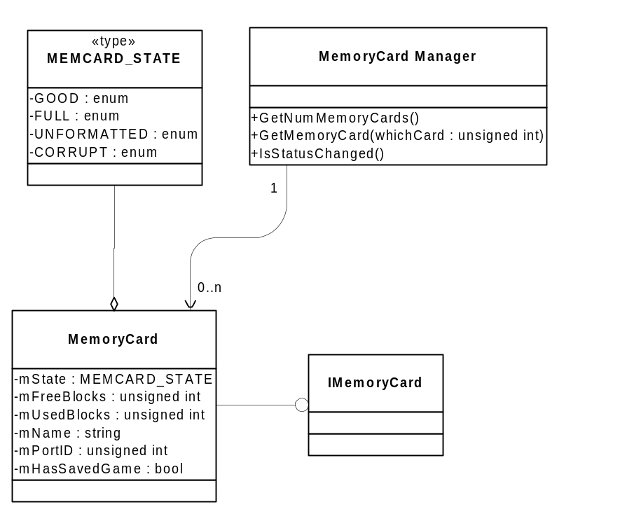
Class hierarchy for MemoryCard

Use Cases

Front End Load Save Game
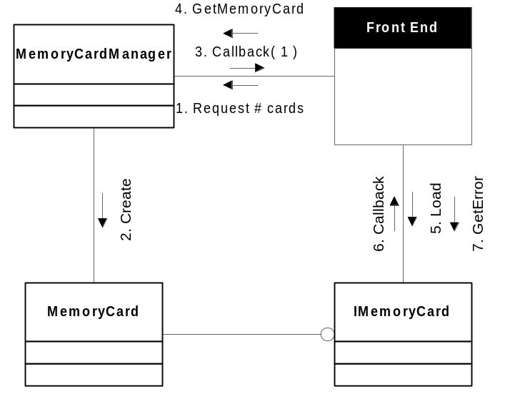
Front End

- Front End requests the number of memory cards. The Front End registers a callback for when the request completes.
- MemoryCardManager creates the MemoryCard with the state of the memory card in slot 0.
- The MemoryCardManager callsback to the Front end to say the request completed and there is one card available.
- Front End gets the available card by calling GetMemoryCard( 0 )
- Front End calls Load() on the IMemoryCard interface returned by the MemoryCardManager. This call registers a callback to the Front End which informs the Front End when the loading is complete.
- The IMemoryCard calls the Front End’s callback which supplies potental load data.
- Before trusting the data sent in the callback, the Front End calls Error on the IMemoryCard to make sure all is well.

